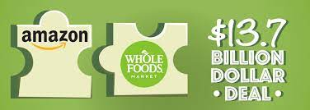

**Analyzing Amazon’s Acquisition of Whole Foods**

Zac Fustgaard, Ariana Gant, Elena Kargopoltsev,

Trevor Pinder, & Raphael Schapiro

(Group 6)

May 30, 2022

**Abstract**

In 2017, Amazon purchased Whole Foods for 13.7 billion dollars. A multi-billion dollar technology company, Amazon has expanded in many directions, now including into the grocery market. Whole Foods, the grocery store chain known for its healthy, organic food and excellent customer service, became the vehicle for Amazon’s entry into the grocery market.

Pre-acquisition, Whole Foods used teams as their management system at every level of the organization, making all major decisions a collaborative effort and giving teams at individual stores a good deal of autonomy. Conversely, Amazon has a clear, centralized hierarchy, with each branch of the company reporting to a group of high level executives who report to the CEO. After the acquisition, the culture of Whole Foods suffered. Amazon imposed strict performance evaluations on workers and started to move away from the autonomous, decentralized management system the company originally had in place.

Despite Whole Foods’ good reputation and company culture, their stock prices had been steadily decreasing over the past 10 years and at the time of the acquisition, the company was 16 billion dollars in debt, an amount that Amazon paid in addition to the 13.7 billion. When it comes to the five forces, the grocery market is moderately unattractive. On the attractive side, the threat of new entrants and supplier power are low. However, buyer power, threat of substitutes, and competitive intensity are high.

Overall, it seems that the acquisition was an excellent choice for Amazon. They have easily entered a whole new industry and have used their technology to grow Whole Foods in a very profitable way. On the other hand, the acquisition may not have been ideal for Whole Foods. Although Amazon helped them out of their financial trouble, their culture and company identity seem to have suffered.

**History of Whole Foods**

Whole Foods was founded in 1980 by four Austin, Texas residents who believed that the natural, organic food industry should move into the supermarket scene. In 1984, the franchise started expanding, gradually moving to other cities in Texas, Louisiana, and California. By the 1990’s, the company had begun to acquire other natural food chains all throughout the country (the Whole Foods website lists 15 such companies that they have acquired). Some of their biggest expansion moves were into Manhattan in 2001, Canada in 2002, and the UK in 2004.[1]

With over 500 locations and nearly 90,000 employees[2], Whole Foods bases its corporate structure on the concept of teams. The company stems from headquarters in Austin, down to the regional offices (12 in the US), out to the distribution centers, which distribute to stores. Every single employee is in at least one team, from the cashiers to the regional managers. At the store level, there are multiple teams for each location, with the employees of each department (produce, bakery, deli, etc) constituting a team. Teams hold each other accountable for poor performance, compete against each other for financial winnings, and make all important decisions together.[3]

**History of Amazon**

Jeff Bezos incorporated Amazon.com in 1994 as a technology company. Starting as a platform to sell books on, the organization was originally met with skepticism, but by October 1997, it had 1,000,000 customer accounts. By 1998, Amazon expanded into music and video sales, and further into the sale of a myriad of other items in 1999. Over time, the company has acquired a number of other organizations and grew to offer services like Amazon Web Services, the Kindle, and Amazon Prime Video.[4]

The organization functions as a vertical hierarchy, with each level of management ultimately reporting to CEO Andy Jassy (the small group of senior executives that report to him directly are called “The S Team”). Geographically, Amazon divides their operations into two divisions: North America and International. The company is also organized by function (distribution, publishing, video production, web services, etc). An important practice within the company is the “two pizza rule”, where no meeting should have more people than can be fed by two pizzas. Stability is also an important characteristic of the company, where high-level executives have a low turn-over rate and have been with the company for many years. Small meeting sizes and stable management contribute to a stable yet flexible organizational structure.[5]

**Culture**

Whole Foods has always considered its unique customer-oriented approach and its organic food to be its competitive advantage, allowing it to have a uniquely loyal brand of customers. Whole Foods was the first grocery store to combine healthy food with an impressive shelf space design. The company's motto is "Whole Foods, Whole People, Whole Planet" and it considers itself "America's healthiest grocery store," a title they worked hard to trademark.[6] Whole Foods' business idea originated from an idealistic desire to help people eat healthy food and has become a pioneer in organic food.

Employees were always treated as important parts of the company, independently building relationships with customers to meet their needs and contributing creative ideas such as new bread recipes or a way to deliver goods on bicycles. Pre-acquisition, the company's managers ran the stores autonomously and had the authority to make product assortment decisions based on customer preferences, carefully selecting a unique range of healthy products that wealthy buyers trust. John Mackey, CEO of Whole Foods, who was retired at 2022 from his position in a message to employees, said: "I have done my best to instill strong values, a clear sense of higher purpose beyond profits, and a loving culture that allows the company and all our interdependent stakeholders to flourish."[7]

This decentralized control and empowerment model has fueled the company's rapid growth across the country, with Fortune magazine naming Whole Foods as one of the best companies in America to work for more than 20 years. However, this decentralized approach led the company to inefficiency and unjustified price increases. After 2013, the company began to lose its market share in favor of stores such as Walmart and Safeway, which started to enter the organic food niche.

Amazon, on the other hand, has established itself as a rapidly developing, affordable, efficient company from the very beginning of its activity. The company's efficiency is based on working with data to manage its product range and enforcing strict employee discipline. This company approach is focused on cost savings, which have translated into benefits for customers. Under Amazon, Whole Foods has developed several consumer benefits, such as online ordering, a pickup service, door-to-door delivery of food at select locations, and perhaps the long-awaited possibility of drone delivery of Whole Foods purchases in the future. After the acquisition, Amazon-Whole Foods moved forward with an inventory system pioneered by activist investors, began centralizing product selection decisions, and reduced the prices of some items by as much as 40%.[8]

When it came to employee culture, Amazon focused on centralization and strict tracking of performance. In collecting statistical data, Amazon uses innovative developments that track quantitative indicators of the performance of employees in the company. The performance of Whole Foods’ employees is measured and evaluated over time to determine how well each person is meeting the company's expectations. This shift imposed new expectations, like the unspoken opinion that if an employee does not help make 66 purchases a day, they will most likely talk with him about his motivation and compliance with the company's goals. With the new culture shift, the staff struggled. In 2021, for the first time in two decades, the company fell out of Fortune's list of the best companies to work for. Employees were frustrated at new innovations and worried about not meeting new performance metrics. These changes in the company's work processes are pushing Whole Foods employees to organize to address changes in corporate culture and reduced compensation.[9]

**Stock Price**

As can be seen in the graph below**[10]**, Whole Foods' highest ever stock price was at $62.84 in January of 2013, when the company was estimated to be worth around 18 billion dollars. One can see that over time, Whole Foods’ price per share dropped significantly since the high of January of 2013, leaving the company in the low $30 range at the time of the acquisition. From the financial perspective of Whole Foods, the acquisition was, to use the words of CEO John Mackey, “A Dream come True.” Mackey described pre-acquisition Whole Foods as "trapped" by the [11]short-term demands of the quarterly earnings cycle, with its profits and stock prices having steadily declined in recent years.[12] Once acquired, the Whole Foods Corporation ceased to have a share in the stock market, as they had been absorbed by Amazon. For Amazon, pre-acquisition shares were worth $845, but increased drastically to $968 per share only two weeks after the acquisition. [13]

In terms of competitors, on the day of the announcement, shares of other big grocery store companies such as Costco, Walmart, and Kroger were hit hard as their shares plummeted. The shares were so badly affected because everyone knew that Amazon was going to make the grocery market more competitive and hit all these companies’ profits margins. 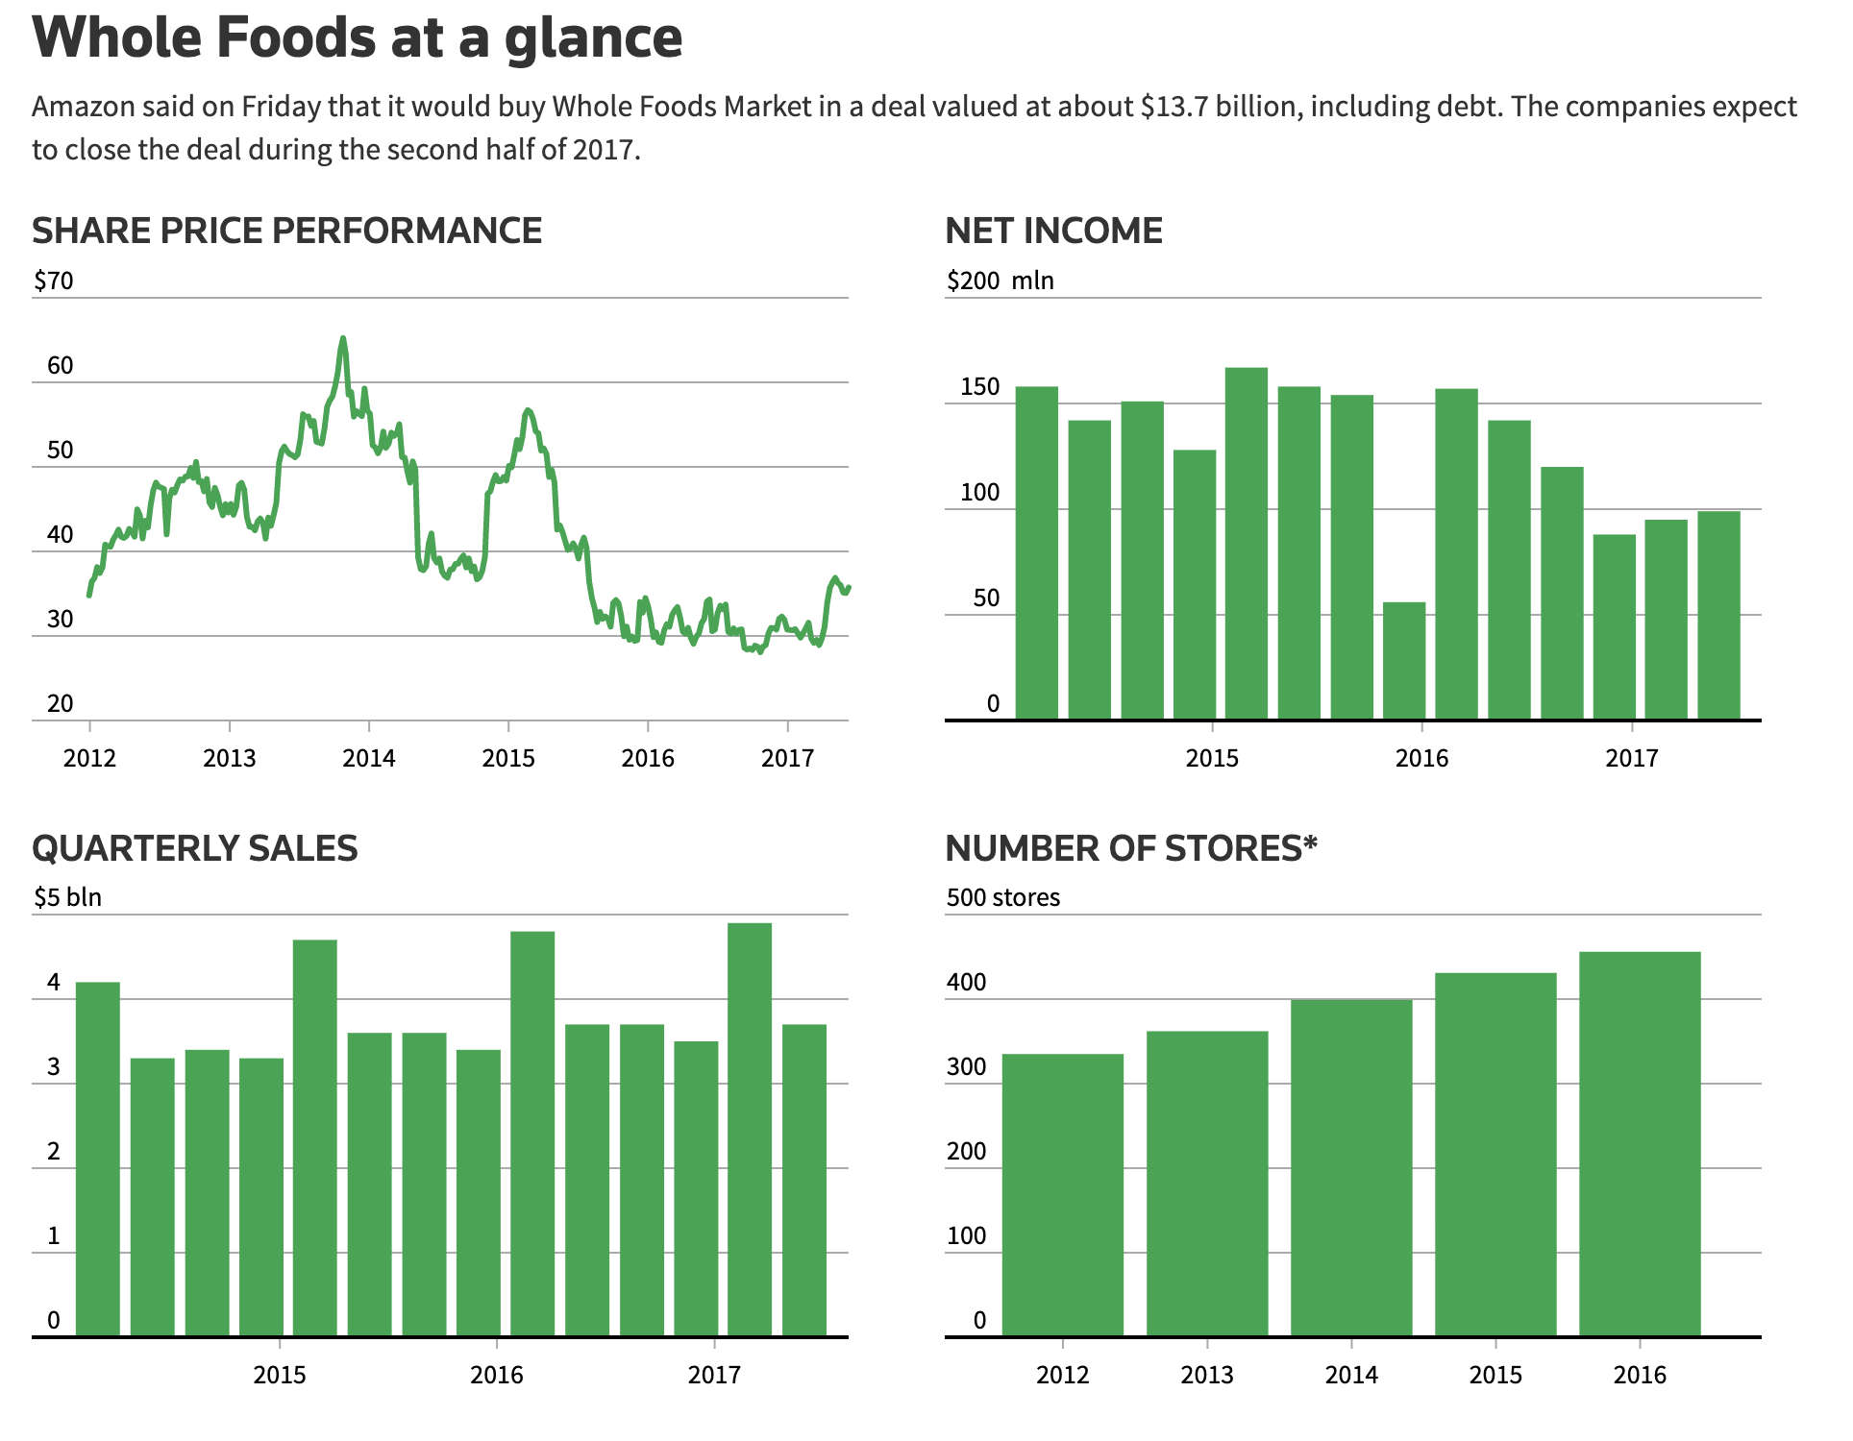

**Cost of Entry**

When Amazon bought Whole Foods for a total of 13.7 billion dollars in 2017, they also agreed to pay off Whole Foods’ net debt of 16 billion dollars that was owed to various investors/companies. With this acquisition, Amazon was entering one of the most competitive markets- the grocery market. However, they had actually already entered the grocery market beforehand with their AmazonGo and AmazonFresh services, which were focused on delivering groceries directly to a user. By acquiring Whole Foods, Amazon was able to gain a significantly larger portion of the grocery market than they had before.

**Threat of New Entrants**

The threat of new entrants in the grocery industry is low. Building up the infrastructure to effectively disrupt Whole Foods would be difficult for a new entrant for a variety of reasons. First, Whole Foods has a first mover advantage in its segment of the grocery industry.[14] Whole Foods is categorized as an upscale grocery retailer that serves a specific segment of the market. It was the first major grocery store retailer that targeted high income individuals who are environmentally conscious, and care about living a healthy lifestyle.[15] The capital requirements associated with entering the supermarket industry are another reason why the threat of new entrants is low. The initial investment for opening a grocery store is massive due to inventory, rent, insurance, and advertising. Grocery stores operate on extremely thin margins (1-3% on average). This means that in order to cover their costs (and turn a profit), high sales volume is necessary.[16] Achieving such a high level of scale would be difficult for new entrants.

**Buyer Power**

Buyer power is high in the grocery industry due to extremely low switching costs, little product differentiation, and high quality information available to customers. With little to no switching costs, it’s easy for customers to switch between competitor grocery retailers. There is also very low differentiation between the products that retailers offer, which results in high buyer power. Most grocery retailers can provide customers with every item on their list. Another reason why buyer power is high is the high quality of information that is available to customers. High quality of information allows customers to browse between multiple stores to find the products they are looking for.

**Supplier Power**

Supplier power in the grocery industry is low due to the large number of grocery store suppliers. As the number of suppliers increases, the supplier power decreases. It is also low because the switching costs for retailers to change suppliers are low. Whole Foods sources its inventory from thousands of local, regional, and national suppliers.[17]

**Threat of Substitutes**

Although the threat of substitutes is moderately high because there are many substitutes for grocery shopping, the majority of U.S. citizens still depend on grocery shopping to feed themselves.[18] That being said, during the pandemic, there has been an increase in the popularity of meal-kit services and subscriptions. While many businesses were adversely affected by the pandemic, the meal-kit industry thrived. The meal-kit segment is expected to grow to generate sales of 10 billion by 2024 (currently generating 6.9 billion).[19] This expected growth could increase the threat of substitutes significantly. One more factor that makes the threat of substitutes moderately high is the low switching costs. It costs customers essentially nothing to switch to eating out at restaurants or to subscribe to meal-kit services.

**Competitive Intensity**

Competitive intensity in the grocery industry is very high. There are many grocery retailers in the industry, which leads to high competitive rivalry. Additionally, firms in the grocery industry compete aggressively over prices, suppliers, products, and quality. One more major variable that increases competitive rivalry is switching costs. Again, the switching costs for customers in the grocery industry are almost nothing. These three factors together make the competitive intensity in the supermarket industry very high.

**Industry Attractiveness**

The grocery industry is moderately unattractive because the majority of the five forces are high. The low supplier power and threat of new entrants make it more attractive for existing grocery retailers, but the most important force in this case is competitive intensity. Amazon was able to enter the grocery industry overnight through acquiring Whole Foods. Amazon could easily afford the $13.7 billion acquisition, but it was somewhat of a risk for the company to acquire such an underperforming target.[20] Overall, the two main factors that make the supermarket industry unattractive are the extremely high competitive intensity, and how difficult it is for firms to gain a differentiation advantage.

**Are Amazon & Whole Foods Better Off?**

Factors like cost position, quality standards, and the synergy of the interacting companies can evaluate if a company that went through a merger or an acquisition is better off or not. In terms of cost position, Amazon acquired Whole Foods for $13.7 billion, so it is important to look at whether that purchase was worth it or not, and if they are forecasted to make a good return on that investment or not. For Amazon’s case, it seems that they are using their expertise in online retail and the infrastructure that the access to Whole Foods stores gives, as well as Whole Foods’ customer base, to try and leverage online grocery. Amazon’s grocery growth has been remarkable and part of that is thanks to leveraging the Whole Foods brands and store infrastructure. However, that growth has been to the detriment of stores, many of which are now effectively mini-fulfillment centers crammed full of pickers (workers who grab products to be delivered) walking the aisles and the shops and restaurants - once a calling card for stores - have been turned into packing area.

In 2020, Amazon saw sales from brick-and-mortar stores — mostly Whole Foods - decline 8%, but Amazon’s 46% sales growth confirms huge online gains, presumably at Whole Foods, as well. Whole Foods also lost market share in 2020. Comparatively, in-store grocery sales at most other retailers, from specialists like Kroger and Sprouts to generalists like Walmart and Target, were up quite a bit in 2020. Overall, grocery spending has been up between 15% and 25% since the pandemic began in March, and yet Whole Foods is an exception, with its stores having not performed well throughout the pandemic. Admittedly, some of this decline is a deliberate part of Amazon’s efforts to shift sales online.[21]

In terms of maintaining quality, on the Whole Food’s end, as mentioned, it seems that Amazon isn’t focusing their efforts on increasing the quality of in-store shopping and their current customer base, but rather focusing on getting out online orders as quickly and efficiently as possible.Whole Foods has not figured out how to leverage its smaller store footprints for e-commerce fulfillment while also maintaining positive unique customer experiences- order pickers do not have the time for customers. It seems that this may be serving Amazon’s current customer base more than Whole Foods. Also, while high standards have remained intact, Whole Foods’ reputation as a leader in discovering and bringing new items to market has taken a hit. Whole Foods now seem to be focusing more on private label brands because of the high margins rather than bringing in new items.

Synergy, defined as “the interaction or cooperation of two or more organizations, substances, or other agents to produce a combined effect greater than the sum of their separate effects,” is another key factor. When making a merger or acquisition, it is important to not only see if the companies are better off financially, but also if they work well together and are better combined then they would be alone or in some other type of relationship.

Looking just at pre vs. post-acquisition Whole Foods, it can be argued that they are not better off after this acquisition. They have lost market share in the grocery business, and seem to be shifting in the direction from a high quality grocer to an efficient distribution center for Amazon’s online fulfillment. From Amazon’s perspective, however, it seems to have been a good decision overall. They obtained access to a wealthy customer base, and can leverage all of that data to increase what they do best- online fulfillment[22]. They also seem to be doing alright in their conquest of competing with the big players in the grocery business, even if that may not have been their overall goal. It is hard to tell if Amazon could have found a different type of alliance with Whole Foods instead of an outright acquisition and get the same benefits, but it seems that to get sole access to the Whole Foods customer base to leverage that data, an acquisition was most likely the best move for Amazon.

1. <https://www.wholefoodsmarket.com/company-info/whole-foods-market-history>
2. <https://fortune.com/best-companies/2017/whole-foods-market/>
3. <https://www.fastcompany.com/26671/whole-foods-all-teams>
4. <https://www.britannica.com/topic/Amazoncom>
5. <https://research-methodology.net/amazon-organizational-structure-2-2/>
6. <https://thegrocerystoreguy.com/what-makes-whole-foods-unique/>
7. <https://www.cnbc.com/2021/09/30/whole-foods-ceo-john-mackey-to-step-down-from-job-in-2022.html>
8. <https://www.aboutamazon.com/news/retail/whole-foods-market-to-launch-just-walk-out-technology-at-two-locations>
9. <https://hbswk.hbs.edu/item/amazon-vs-whole-foods-when-cultures-collide>
10. <https://fingfx.thomsonreuters.com/gfx/rngs/WHOLEFOODS-MA/010041MH3JK/index.html>
11. <https://www.businessinsider.com/amazon-whole-foods-takeover-stock-price-gains-2017-6>
12. <https://www.cnbc.com/2017/08/15/amazons-debt-offering-to-fund-whole-foods-acquisition-includes-40-year-bond.html>
13. <https://www.benzinga.com/money/buy-whole-foods-stock/>
14. <https://www.forbes.com/sites/gregpetro/2017/08/02/amazons-acquisition-of-whole-foods-is-about-two-things-data-and-product/?sh=243bb323a808>
15. <https://thegrocerystoreguy.com/why-is-whole-foods-more-expensive/#:~:text=Whole%20Foods%20costs%20between%2010,service%2C%20and%20better%20product%20knowledge>.
16. <https://smallbusiness.chron.com/profit-margin-supermarket-22467.html>
17. <https://www.winsightgrocerybusiness.com/retailers/whole-foods-market-names-suppliers-year#:~:text=Whole%20Foods%20Market%20recently%20recognized,company's%20ninth%20annual%20Supplier%20Awards>.
18. <https://www.statista.com/statistics/251728/weekly-number-of-us-grocery-shopping-trips-per-household/>
19. <https://www.statista.com/statistics/761621/meal-kit-delivery-service-market-value/#:~:text=Fresh%2Dfood%20meal%20kits%20are,for%20over%20ten%20billion%20dollars>.
20. <https://www.investopedia.com/news/why-whole-foods-amazons-biggest-risk/>
21. <https://www.freightwaves.com/news/has-amazon-spoiled-whole-foods>
22. <https://www.cnbc.com/2018/06/15/a-year-after-amazon-announced-whole-foods-deal-heres-where-we-stand.html>